
MANSFIELD PLUMBING PRODUCTS, L.L.C.

REQUEST FOR BATHWARE TECHNICAL ASSISTANCE

Before contacting MPP, please troubleshoot the following problems with the customer.
PROBLEMS | SOLUTIONS
Whirlpool system leaking | - If the leak seems to originate at one or both pump connections (unions), call the installer. The installer will need to check the tightness of the pump unions.  - If occasional leaks seem to originate at the bath overflow, tighten down the overflow to the tub.  - Other leaks, mark area on whirlpool pictures below and contact MPP.
The whirlpool will not start | - Check for improper or loose electrical connections, open switch for relays, blown circuit breaker or fuses.  - Check to see if the clear tubing from the air switch to the pump is attached.
The whirlpool motor stops or makes a noise | - Check for loose wiring or connection.  - Check for low voltage at motor (frequently caused by undersized wiring).  - Check for air leak in suction line causing a rumbling in pump.  - Check for improper mounting or vibration causing pump to become loose from its mounting.
Low flow, generally | - Check for obstructions in the suction line.  - Check voltage to make sure pump is up to speed.  - Check for obstructions in the discharge line.  - Check for an obstructed or restricted impeller.

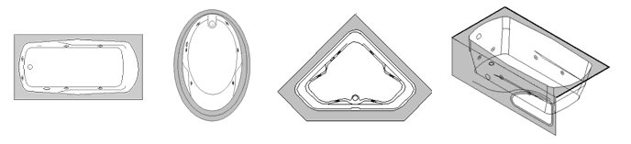
If the problem is not solved, please fill out the following information entirely. A work order and service appointment will not be scheduled if any information is missing. The information requested below is essential for MPP to properly identify the problem, send the correct parts and expedite the repair.

Contact Information
Contact Name: |  | Primary Phone No. |  | Alt. Phone No.
Alt. Contact: |  | Primary Phone No. |  | Alt. Phone No.
Service Address
Address:
City: |  | State: |  | Zip:
Unit Information
Serial No. |  | Model: |  | Color:
Description of Problem

